**Performance Engineering Services (PES)**

**Process Document**

Contents

**1.1** **About this Document** 3

**1.2** **Intended Audience** 3

**1.3** **Abbreviations** 3

**2.** **Objectives** 3

**2.1** **Performance Engineering** 4

**2.2** **Performance Testing** 4

**2.3** **Service Virtualization** 4

**3.** **Engagement Model** 4

**3.1** **PES Engagement Models** 4

**3.2** **Out-of-Scope Items** 5

**3.3** **PES Workflow** 6

**3.4** **PES Deliverables** 6

**4.** **Deliverables** 6

**4.1** **Performance Test Plan** 6

**4.2** **Performance Scripting** 6

**4.3** **Performance Testing Execution** 6

**4.4** **Performance Analysis and Reporting** 7

**5.** **Procedures, Activities, and Tasks** 7

**5.1.3** **Test Plan Activities & Deliverables** 8

**5.1.4** **Reference Templates - Dynamic Code / UI Profiling Observations** 8

**5.1.5** **Analysis & Reporting** 9

**7.** **Key Practice Areas** 11

**8.** **Quality Assurance Plan** 11

**9.** **PES Communication & Reporting** 11

**9.1** **Weekly Status Report** 11

**9.2** **Performance Test Plan** 11

**10.** **Out of Scope Items** 12

11. Project Execution Model 12

12. Team Information 12

13. Technologies & Tools 12

**Conclusion** 13

1. **Introduction**
   1. **About this Document**

This document serves as a reference for all aspects of Performance Engineering Services (PES) engagement, operating model and provides a detailed description of the PES objectives, processes, and procedures that the team shall follow for all applications in the engagement.

* 1. **Intended Audience**

The intended audience of this document includes:

* Performance Engineering Services (PES) Team
* Application Team
* Test Manager
* Project Manager
* Release Manager
* Business Analysts
* System Architects
* Developers
* Subject Matter Experts (SMEs)
* External stakeholders such as the Customer, Administration staff, Operations and Support, Business Project Manager, Procurement Manager, CTO, External vendors, and owners of any internal systems within the organization
  1. **Abbreviations**
* **APM** – Application Performance Monitoring
* **BAU** – Business as Usual
* **EPT** – Early Performance Testing
* **MOE** – Merger of Equals
* **NFR** – Non-Functional Requirements
* **PC** – Microfocus Performance Center
* **PE** – Performance Engineering
* **PES** – Performance Engineering Services
* **PT** – Performance Testing
* **PVA** – Performance Vulnerability Assessment
* **QES** – Quality Engineering Services
* **SDLC** – Software Development Life Cycle
* **SLA** – Service Level Agreement
* **SV** – Service Virtualization
* **BZM** - Blazemeter

1. **Objectives**
   1. **Performance Engineering**

Performance Engineering is a software-oriented approach focused on optimal selection of application architecture, design, and implementation choices to meet Non-Functional Requirements (NFRs). It involves tasks across the Software Development Life Cycle (SDLC), including:

* NFR gathering
* Early performance testing
* Dynamic code profiling
* Engineered performance testing
  1. **Performance Testing**

Performance testing is executed to validate and verify the qualitative and quantitative attributes of a system. It assesses aspects such as:

* Response times
* Throughput (transactions per second)
* Hits per second
* Error rates
* Resource utilization

Each performance testing objective has:

* **Key Performance Indicator (KPI)** – The desired value to be achieved
* **Performance Threshold** – The maximum acceptable value
  1. **Service Virtualization**

Service Virtualization enables testing and validation of application components in simulated environments, allowing early identification of potential performance issues. With PES, this helps mitigate risks by replicating real-world scenarios and ensuring consistent test conditions.

1. **Engagement Model**
   1. **PES Engagement Models**

**Engagement Model 1:**

For the following requests types: Business as Usual (BAU), Merger of Equals (MOE), New Application, the Requestor* submits a PVA form to determine performance test needs

*Please note that the PVA should be submitted by someone with application domain knowledge and environment details such as the application technical lead and/or architect

**Engagement Model 2:**

For the following requests types: Production Incident / Problem Ticket, Ad Hoc / Non Application Request, Proof of Concept, the Requestor** directly submits the Intake form to obtain PES services

**Please note that the PES form should be submitted by the test manager

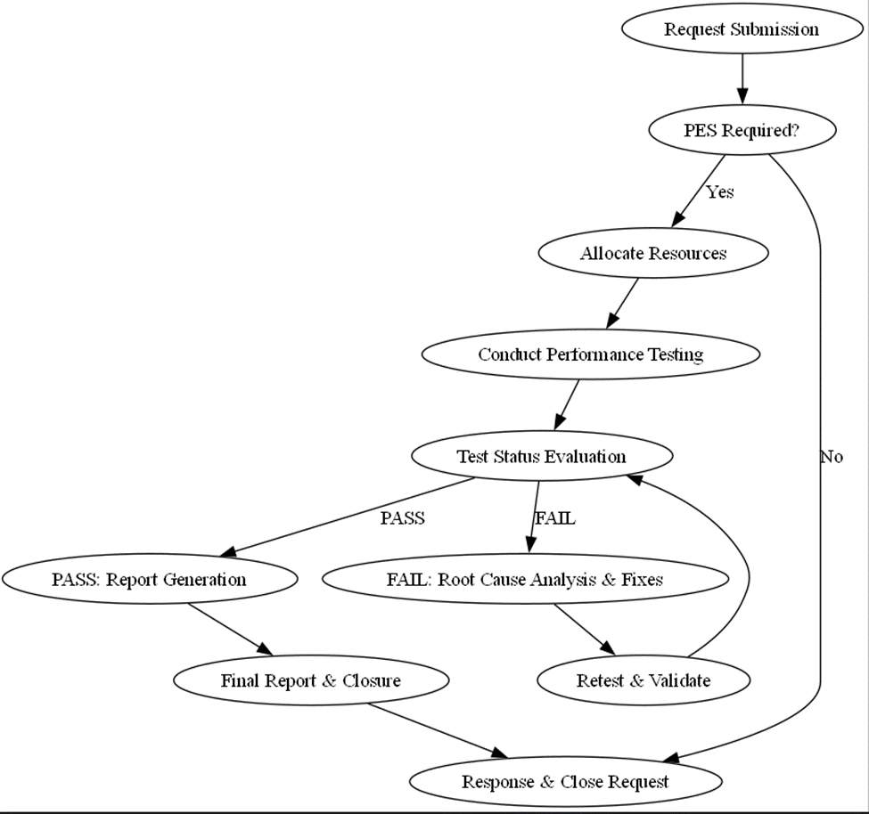

* 1. **Out-of-Scope Items**

PES does **not** cover:

* Functional testing
* Test data creation
* Batch Performance Testing (setup, dependencies, execution)
* Code deployment
* Environment readiness
* Performance tuning recommendations
* Code-level root cause analysis without instrumentation
  1. **PES Workflow**

1. **Request Submission** – PES request reviewed.
2. **Decision Point: Is PES Required?**
   * Yes → Proceed with PES resource allocation.
   * No → Provide response and close request.
3. **Resource Allocation** – Assign resources and define scope.
4. **Test Execution** – Monitor performance metrics.
5. **Evaluation**
   * Pass → Report generation.
   * Fail → Identify root cause, fix, and retest.
6. **Final Report & Closure** – Document findings, recommend actions, and close request.
   1. **PES Deliverables**

|  |  |  |
| --- | --- | --- |
| Deliverable | Stakeholder(s) | Usage |
| Performance Vulnerability Assessment Outcome | PVA Requester | External |
| Performance Test Plan | Project Manager, Technical Lead, Business Analyst | External |
| Traversal Flow Document | PES Team | Internal |

1. **Deliverables**
   1. **Performance Test Plan**

* Define scope for performance testing
* Tool evaluation and proof of concept execution
* Define Early Performance Testing (EPT) scope
* Identify environment
* Define code base
* Define test cases and volume
* Performance test plan review and sign off
  1. **Performance Scripting**
* Test script development/manage test scripts
* Preparation of performance testing
  1. **Performance Testing Execution**

Includes:

* Test execution and server monitoring
  + Load Test
  + Stress Test
  + Endurance/Soak Test
* EPT execution and monitoring
* Dynamic Code/UI Profiling
  + Define scope/identify problematic transactions
  + Identify tools and environment
  + Access to application server
  + Execute single user test and profile
  + Identify and analyze hotspots
  + Deliver profiling observations
  1. **Performance Analysis and Reporting**
* Root cause analysis
* Defect logging
* Test result analysis
* Performance Test Summary Report distribution
* Review and sign off

1. **Procedures, Activities, and Tasks**
   1. **Performance Vulnerability Assessment (PVA)** This phase is the first step of Performance Engineering Services to assess the performance risk for an application. The PVA is an online form which helps in determining whether an application requires performance engineering services. The PVA should be submitted by someone who has application and domain knowledge and who is interested in assessment for performance testing or related services. The PVA is used to determine risk related to application or infrastructure changes as well as taking into account business criticality. The Performance Engineering Team, along with the Requester and/or designee, will assess the PVA Form and determine whether performance engineering is Required, Recommended, or Not Required.
      1. **PVA Activities & Deliverables**

* **Entry Criteria:** PVA request submitted
* **Tasks:**
  + PVA review assigned by PES Manager to PES Lead
  + PVA reviewed by Performance Engineering Lead
  + Completion of PVA reference xls by the assigned PE Lead and saved to QES SharePoint
  + Communication with requester as needed should additional information be required
* **Deliverables:** Completed PVA
* **Exit Criteria:** PVA outcome communicated
  + 1. **PVA Stakeholders & Responsibilities**

| **Stakeholder** | **Responsibilities** |
| --- | --- |
| Onsite Performance Manager | Assigns PVA review |
| Onsite Performance Lead | Reviews PVA, communicates with requester, saves PVA reference |

* + 1. **Test Plan Activities & Deliverables**
* Clarify Business requirement queries with Business Analyst or SIT/FIT team to complete Traversal Flow Document
* Identify the Test Scenarios and test approach based on the following information:
  + NFR/SLA
  + Volumetric
  + Type of Test to be carried out
* Prepare detailed activity and timeline plan
* Define performance test environment specification in comparison with production
* Setup instrumentation to enable performance engineering activities
* Define the performance monitoring counters and initiate the setup process in performance test environment
* Identify risk and mitigation actions
* Identify suspension, resumption and exit criteria
* Prepare, review and rework on the Performance Test Plan
* Prepare, review and rework on the Business Traversal Flow document
* Conduct performance test plan walkthrough workshop
* Conduct risk discussion workshop, if needed
* Revise performance test plan based on review comments, if required
* Work with Test Manager or application team to remediate any environment issues
* Execute Proof of Concept, if required

**Deliverables:**

* Traversal Flow doc (internal)
* Performance Test Plan

**Exit Criteria:**

* Sign-Off on Performance Test Plan
  + 1. **Reference Templates - Dynamic Code / UI Profiling Observations**
* Development Manager:
  + Analyze or facilitate to analyze the performance bottlenecks
  + Provide recommendations for code optimizations
* Project Manager:
  + Help orchestrate and facilitate any support required by Performance Engineering Service team
  + Track performance engineering progress against plan
  + Facilitate access to code profiling tools
  + Responsible for providing environment for profiling
  + Responsible for providing stable build and test data
    1. **Analysis & Reporting**
* Test results will be analyzed after each performance test run for response times and resource utilization. The business transactions that do not meet the performance acceptance criteria in terms of response times or transactions per second (TPS) will be reported and analyzed.
* For analysis purposes, the test run results corresponding to steady state (when all the virtual users have completed at least one iteration of the test script) will be considered as it gives a more realistic picture due to caching of the scenarios. Further analysis can be carried out using application server logs or AWR Reports on need basis.
* All performance defects will be logged in H ALM for tracking and closure. The defects may be assigned to the Application Development Team.
* A "PASS" decision will not be provided by the Performance Engineering Service Team unless all severity 1 and severity 2 defects are resolved.
* Defect trend analysis to be performed periodically to avoid the defect leakage.
* **Entry Criteria:** Test execution complete
* **Tasks:**
  + Analyze results
  + Log defects in ALM
  + Prepare & distribute Performance Test Summary Report
* **Exit Criteria:** Report finalized

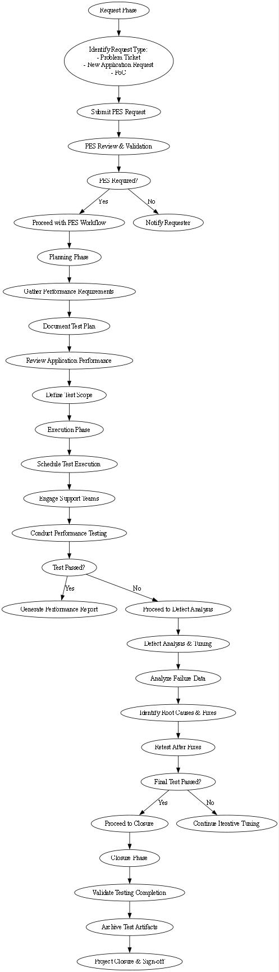

1. **Key Practice Areas**

* **PVA Assessment** – Performance risk evaluation
* **NFR Gathering** – Validate requirements
* **Test Planning** – Define scope & tools
* **Scripting & Execution** – Develop & run tests
* **Analysis & Reporting** – Log defects & generate reports

1. **Quality Assurance Plan**

* Capture metrics for PVA requests, test executions, and defect tracking.

1. **PES Communication & Reporting**
   1. **Weekly Status Report**

* The Performance Engineering Services team delivers to the application stakeholders status reports on the overall application execution status and issues faced through the following format.
* **Type Report:** Status Report
* **Frequency:** Weekly
* **Prepared By:** Performance Engineering Lead
* **Sent to:** Project Manager, Technical Lead, Solution Architect, Business Analyst, Production Support Tier 3, Production Support Tier 2, PES Client Manager, PES Manager, Any other Project defined Stakeholder
  1. **Performance Test Plan**
* Information collected via the requirements xls is input to the design of the PES test plan. Test Plan sign-offs are stored in the PES SharePoint and migrated over to the PES Shared Drive for permanent storage per policy.
* **Type of Document:** Test Plan
* **Frequency:** Any application in PES scope
* **Prepared By:** Performance Engineering Lead
* **Test Plan Approvers:** Project Manager, Technical Lead, Solution Architect, Business Analyst/Line of Business Sponsor, Application Delivery Manager, Any other Project defined Stakeholder
* **Test Plan Reviewers (CC only, signature not required):** Production Support Tier 3, Production Support Tier 2, PES Client Manager, PES Manager
  1. **Performance Test Summary Report**
* Final performance test summary reports are distributed over email with "FINAL" in the subject line, indicating final results for all PES testing scope (i.e. this is the conclusion to all performance test types in scope: load, stress, etc.)
* **Type of Document:** Performance Test Summary Report
* **Frequency:** Any application in PES scope
* **Prepared By:** Performance Engineering Lead
* **Sent to:** Project Manager, Technical Lead, Solution Architect, Business Analyst/Line of Business Sponsor, Application Delivery Manager, Any other Project defined Stakeholder
* **Test Plan Reviewers (CC only, signature not required):** Production Support Tier 3, Production Support Tier 2, PES Client Manager, PES Manager

|  |  |  |  |
| --- | --- | --- | --- |
| Report Type | Frequency | Prepared By | Sent To |
| Status Report | Weekly | PES Lead | PM, Tech Lead, PES Manager |
| Test Plan | Per Application | PES Lead | Project Stakeholders |
| Test Summary Report | Per Application | PES Lead | PM, Tech Lead, Business Analyst |

1. **Out of Scope Items**

PES does **not** include:

* Functional testing
* Test data creation
* Batch performance tuning
* Code deployment & environment setup
* Performance tuning recommendations

## Project Execution Model

* **Primary Model:** Waterfall

## Team Information

|  |  |  |
| --- | --- | --- |
| Team | Onsite (ON) | Offshore (OFF) |
| NFT | 10 | 25 |
| PE | 1 | 3 |

## Technologies & Tools

#### Performance and APM Tools

* LoadRunner, JMeter, Performance Center (LRE), Blazemeter, Dynatrace, Splunk, AWS

#### Technology Stack

* Java, .NET, Mulesoft, TIBCO, AWS, PEGA, Mainframe, IVR, Microservices, RTP, Payment Hub (Finastra)

#### Services Provided

* Performance Testing, Performance Engineering, Service Virtualization

#### Locations

* Kolkata, Chennai, Hyderabad, Atlanta, Raleigh

#### Teams Included

* NFT, PACE, QEA (SV)

**Conclusion**

This document serves as a guide for PES engagement, process, and deliverables. It ensures a structured approach to Performance Engineering, focusing on proactive assessment, thorough testing, and robust analysis for optimized system performance.